1.List the notations of ER diagram.

1. Entities
- Strong Entity – Represented by a rectangle
- Weak Entity – Represented by a double rectangle

2. Attributes
- Simple Attribute – Oval (e.g., Name, Age)
- Key Attribute – Oval with an underline
- Multivalued Attribute – Double oval
- Derived Attribute – Dashed oval

3. Relationships
- Regular Relationship – Diamond shape
- Weak Relationship – Double-bordered diamond

4. Cardinality Constraints
- One-to-One (1:1)
- One-to-Many (1:M)
- Many-to-Many (M:N)

5. Specialization and Generalization
- Generalization/Specialization – Triangle

6. Aggregation
- Represented by enclosing a relationship and entity inside a rectangle

2.Draw an ER diagram for the following:
#### Entities:
1. **Student:**
- Attributes: StudentID (Primary Key), Name, Date of Birth, Address, Phone Number, Email

2. **Course:**
- Attributes: CourseID (Primary Key), Course Name, Department, Credits

3. **Instructor:**
- Attributes: InstructorID (Primary Key), Name, Department, Email

#### Relationships:
1. **Enrollment:**
- Many-to-Many relationship between Student and Course entities.
- Attributes: EnrollmentID (Primary Key), Date Enrolled, Grade
- Include associative entity to represent the relationship.

2. **Teaching:**
- One-to-Many relationship between Instructor and Course entities.
- Attributes: TeachingID (Primary Key), Semester, Year

#### Tasks:
1. Create an Entity-Relationship Diagram (ERD) for the university database system based on the given entities and relationships.
2. Ensure appropriate cardinality and participation constraints are represented.
3. Identify and specify the primary key for each entity.
4. Indicate foreign keys in the relationships.

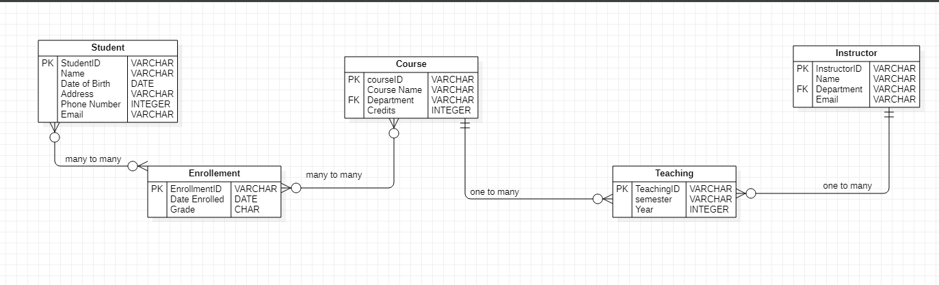

3.Notations of a Class Diagram (Short Summary)
- Class – Rectangle with three sections: Class Name, Attributes, and Operations.
- Attributes – Listed in the middle section (+name: String).
- Operations – Listed at the bottom (+getAge(): int).
- Aggregation – Hollow diamond (Weak "has-a" relationship).
- Composition – Filled diamond (Strong "has-a" relationship).
- Inheritance – Arrow with an empty triangle (Represents "is-a" relationship).
- Multiplicity – Defines relationships (e.g., 1, 0..1, *, 1..*).

Q2.Draw a Class diagram for the Online Bookstore System.
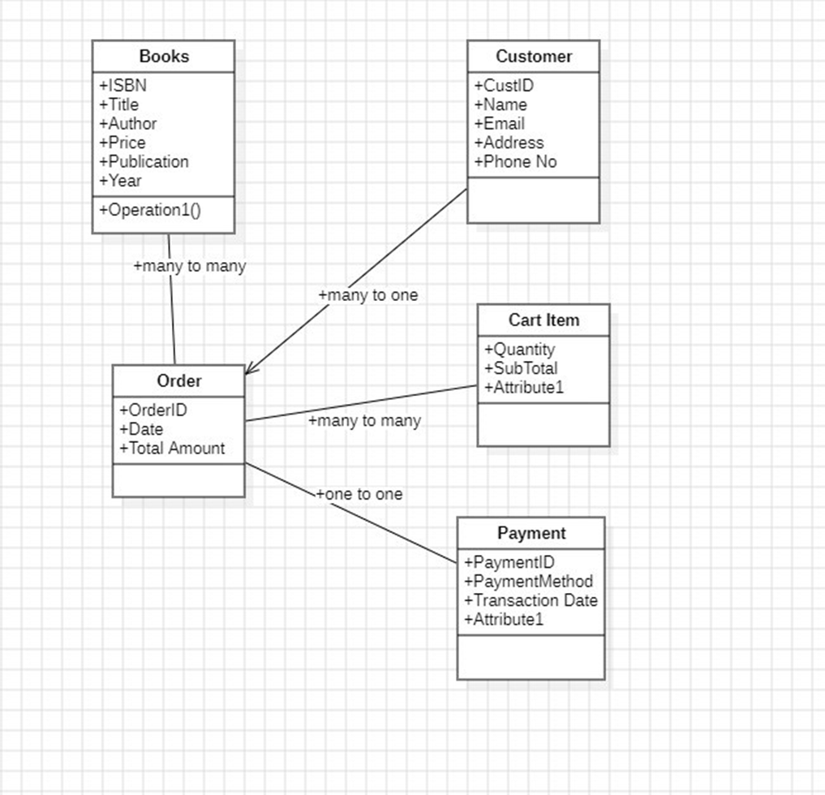

Q3 We want to model a system for managing flights and pilots. An airline operates flights. Each airline has an ID. Each flight has an ID a departure airport and an arrival airport: an airport as a unique identifier.
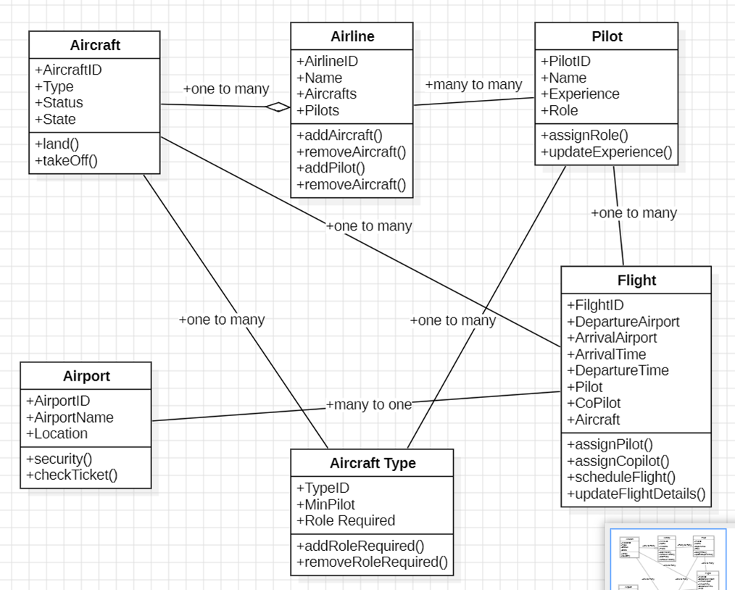

Draw USE CASE diagram for Library management system.
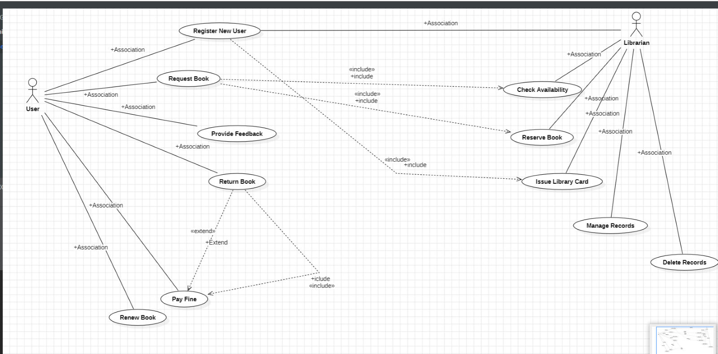

What is USE CASE diagram? List the notations and relationship in USE CASE diagram
Use Case Diagram (Short Summary)
- Definition – A UML diagram showing interactions between users (actors) and a system to achieve specific goals.
- Notations:
  - Actor – Stick figure 👤 (user or external system).
  - Use Case – Oval shape (functionality).
  - System Boundary – Rectangle enclosing use cases.
- Relationships:
  - Association – Straight line (actor ↔ use case).
  - Include (<<include>>) – Dotted arrow (mandatory use case).
  - Extend (<<extend>>) – Dotted arrow (optional use case).
  - Generalization – Arrow with empty triangle (inheritance).

Activity diagram

1. What is an Activity Diagram?
An Activity Diagram is a UML diagram that represents the workflow of activities in a system, describing how tasks, actions, and decisions flow from one to another. It is used to model business processes and system logic.
2. Notations in an Activity Diagram:
- Initial Node – Black filled circle (starting point of the workflow).
- Activity (Action) – Rounded rectangle (represents a task or action).
- Decision Node – Diamond shape (used for branching with conditions).
- Control Flow – Arrow (shows sequence and direction of execution).
- Merge Node – Diamond shape (joins multiple flows into one).
- Fork Node – Thick bar (splits a process into parallel tasks).
- Join Node – Thick bar (merges parallel tasks into one).
- Final Node – Black filled circle with an outer ring (end of the process).

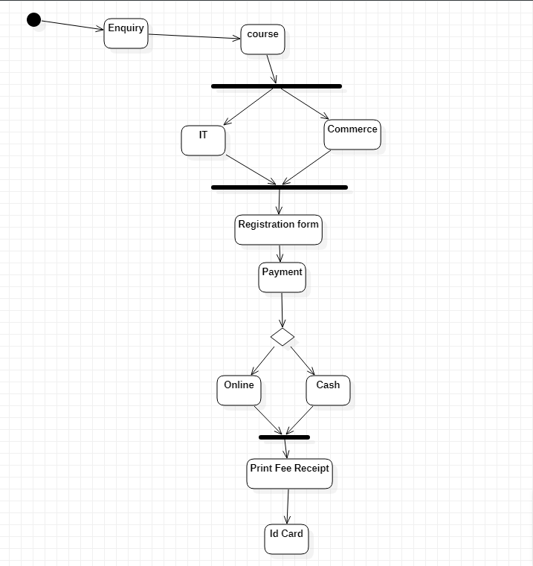

Library Management

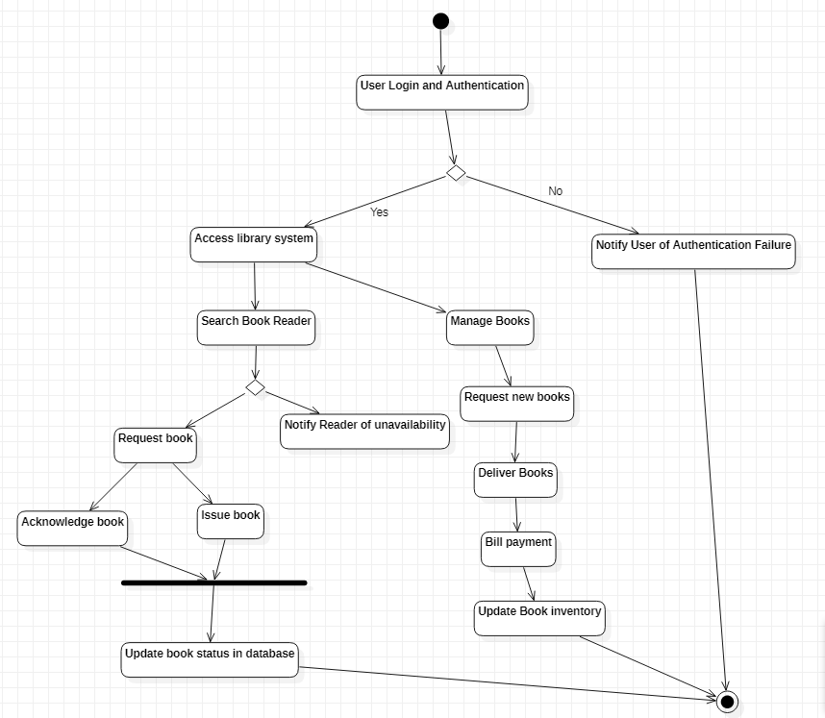

ATM


1. What is a Sequence Diagram?
A Sequence Diagram is a UML diagram that represents how objects interact over time through message exchanges. It is used to model the flow of messages in a system and visualize interactions between different components or users.
2. Notations in a Sequence Diagram:
- Actor – Stick figure 👤 (represents a user or external system).
- Object – Rectangle with object name (represents an instance of a class).
- Lifeline – Dashed vertical line extending from an object (represents its existence).
- Activation Bar – Thin rectangle on the lifeline (represents active execution).
- Message (Synchronous) – Solid arrow with filled head (caller waits for a response).
- Message (Asynchronous) – Solid arrow with open head (caller doesn’t wait for a response).
- Return Message – Dashed arrow (response from a called function).
- Self-Message – Arrow looping back to the same object (recursive call).

Q2. Draw a Sequence Diagram for the following:
Scenario: Online Shopping Checkout Process

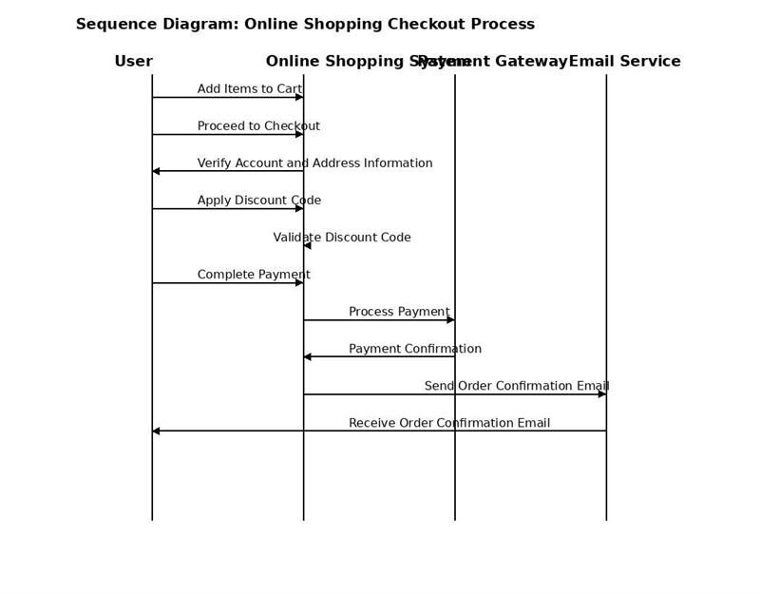

Q2)What is a State Transition Diagram?
A State Transition Diagram (or State Machine Diagram) is a UML diagram that represents the states of an object and the transitions between those states based on events. It is used to model dynamic behavior in a system.
2. Notations in State Transition Diagram:
- State – Rounded rectangle representing a specific condition of an object.
- Initial State – Black filled circle (starting point).
- Final State – Black filled circle with an outer ring (end point).
- Transition – Arrow connecting states (represents state change due to an event).
- Event/Trigger – Label on a transition arrow describing the cause of state change.

Draw a state chart diagram for:
A company is developing a smart home automation system
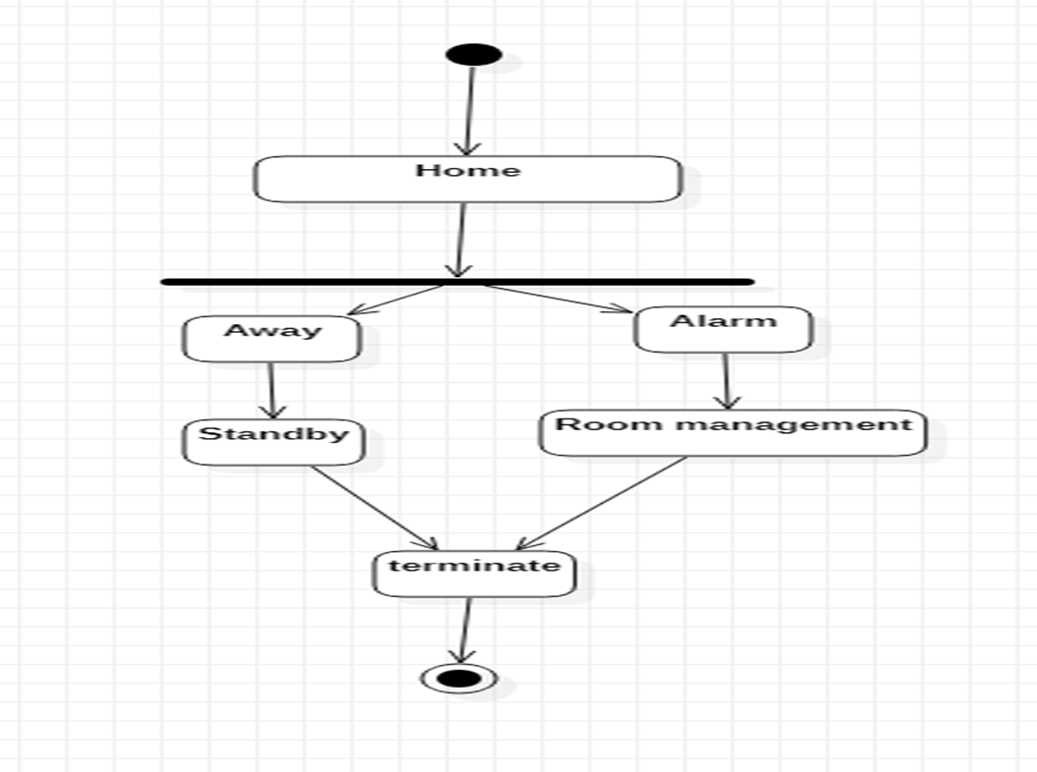

Draw a State Transition Diagrams for Learning Management System.
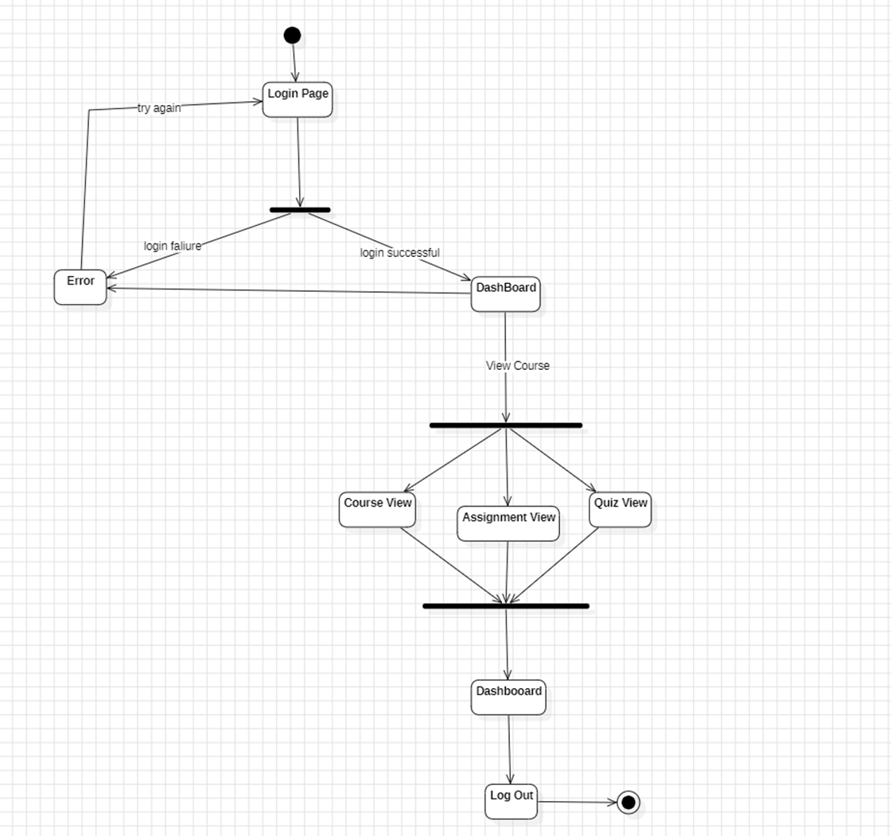

Draw a Data Flow Diagram for bank transaction system.
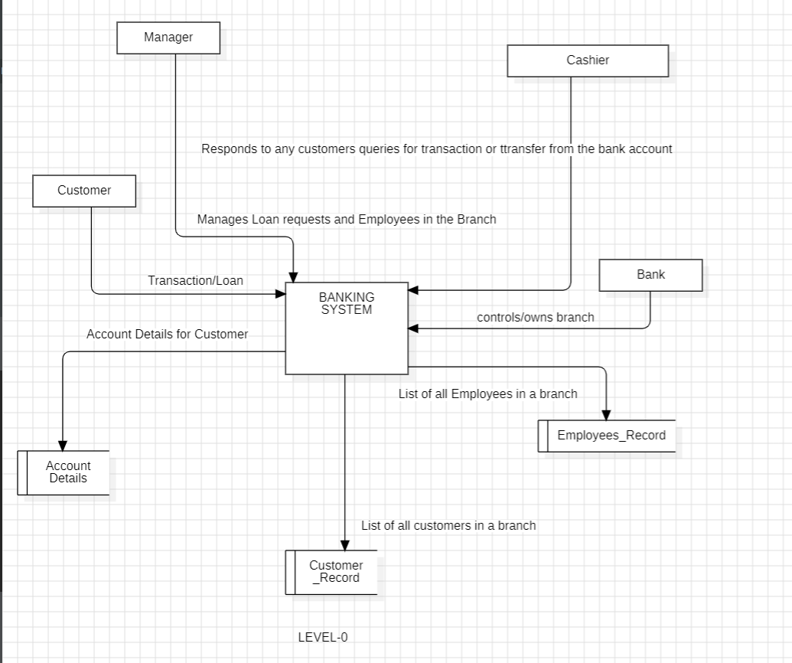

Study and implementation of Data Flow Diagram for Online Movie Ticket Booking
System.
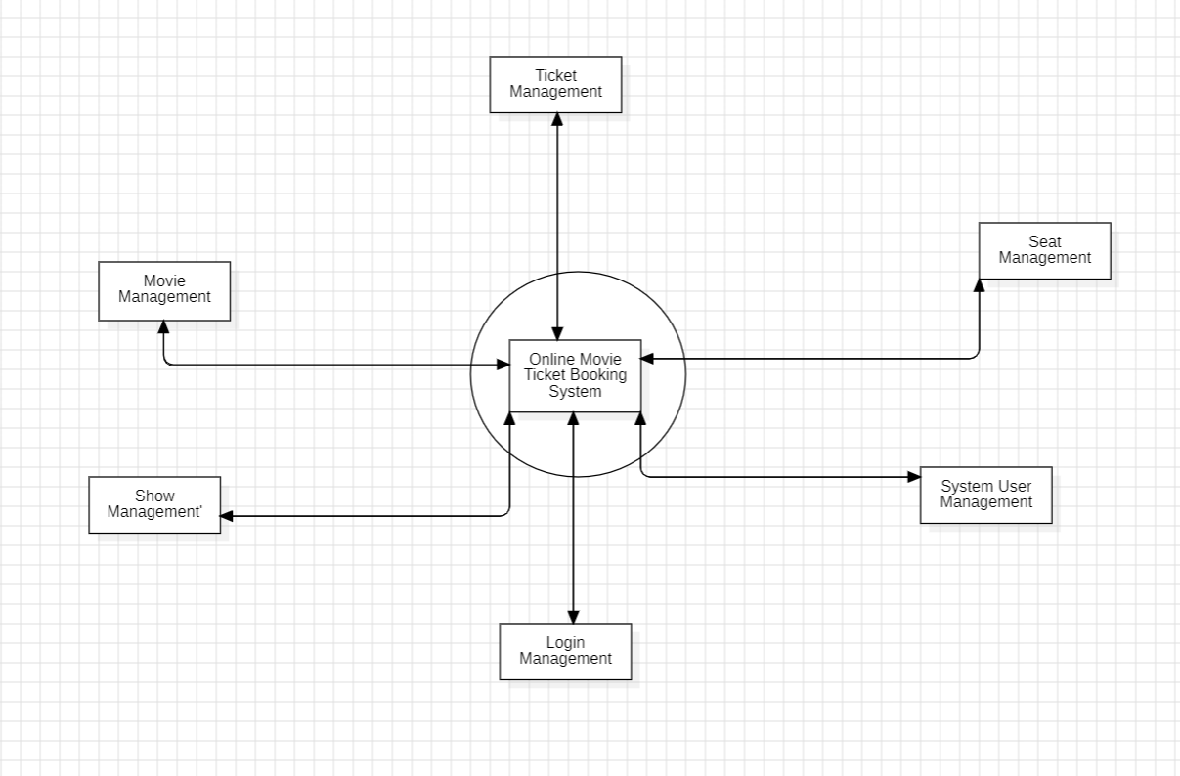

1. What is a Data Flow Diagram (DFD)?
A Data Flow Diagram (DFD) is a graphical representation of how data moves through a system. It shows processes, data inputs, outputs, storage, and data flow within a system. DFDs help in system analysis and design by visualizing data transformation.
2. Notations in a Data Flow Diagram:
- Process – Circle or Rectangle with rounded corners (Represents a function or operation that processes data).
- Data Flow – Arrow (Represents the movement of data between components).
- External Entity – Rectangle (Represents external sources or destinations of data).
- Data Store – Two parallel lines or an open-ended rectangle (Represents a database or file storing data).

Draw Collaboration Diagram for Library Management system.

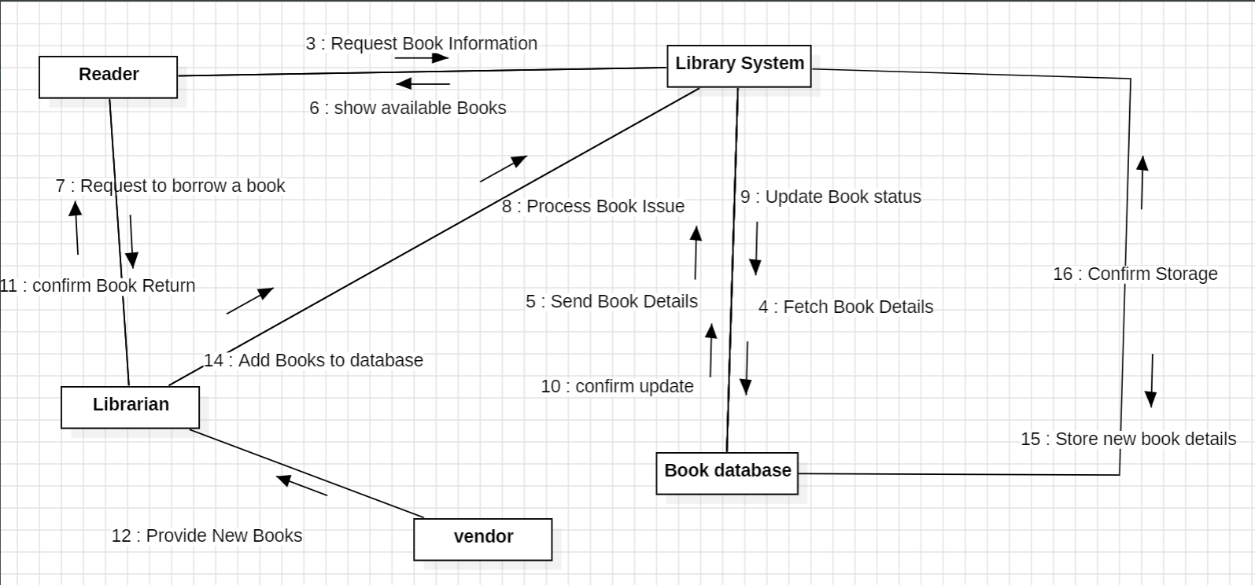
2.
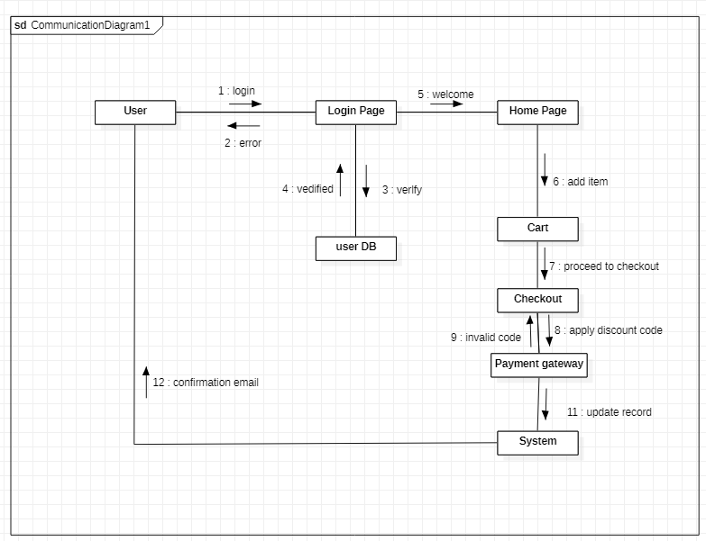

- Draw Collaboration Diagram for Railway Management system.
- 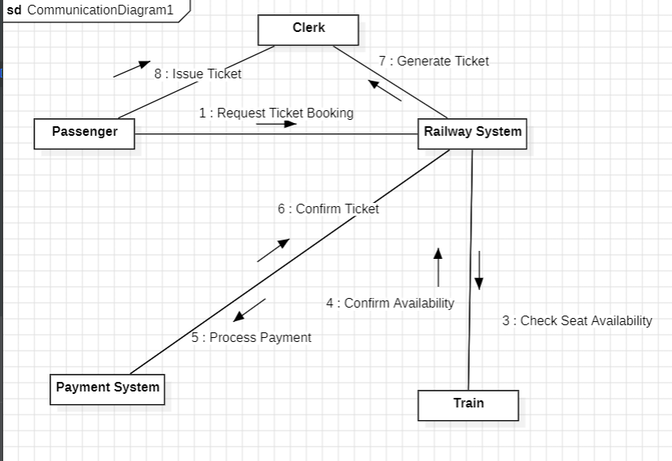

Deployment Diagram in Software Engineering
A Deployment Diagram is a UML diagram that represents the physical architecture of a system by showing how software components are deployed on hardware. It helps visualize the hardware devices (nodes), software artifacts, and communication paths between them.
Notations in Deployment Diagram
- Node – Represents hardware devices like servers, mobile phones, etc. (Notation: 3D Cube).
- Artifact – Represents software components or files deployed on nodes (Rectangle with a folded corner).
- Communication Path – Shows connections between nodes (Solid Line).
- Device – Special node for hardware devices (Labeled <>).
- Execution Environment – Represents software platforms like JVM, Docker (Labeled <>).
Example: A web application with a Client, Web Server, and Database Server communicating via the internet.

Draw Deployment Diagram for Embedded System Project .
